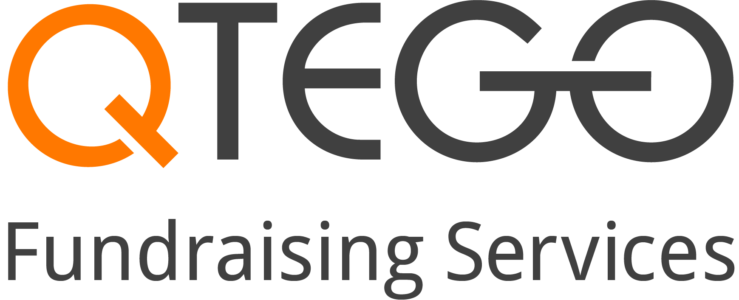
How to Register and Bid
on Auction Items!

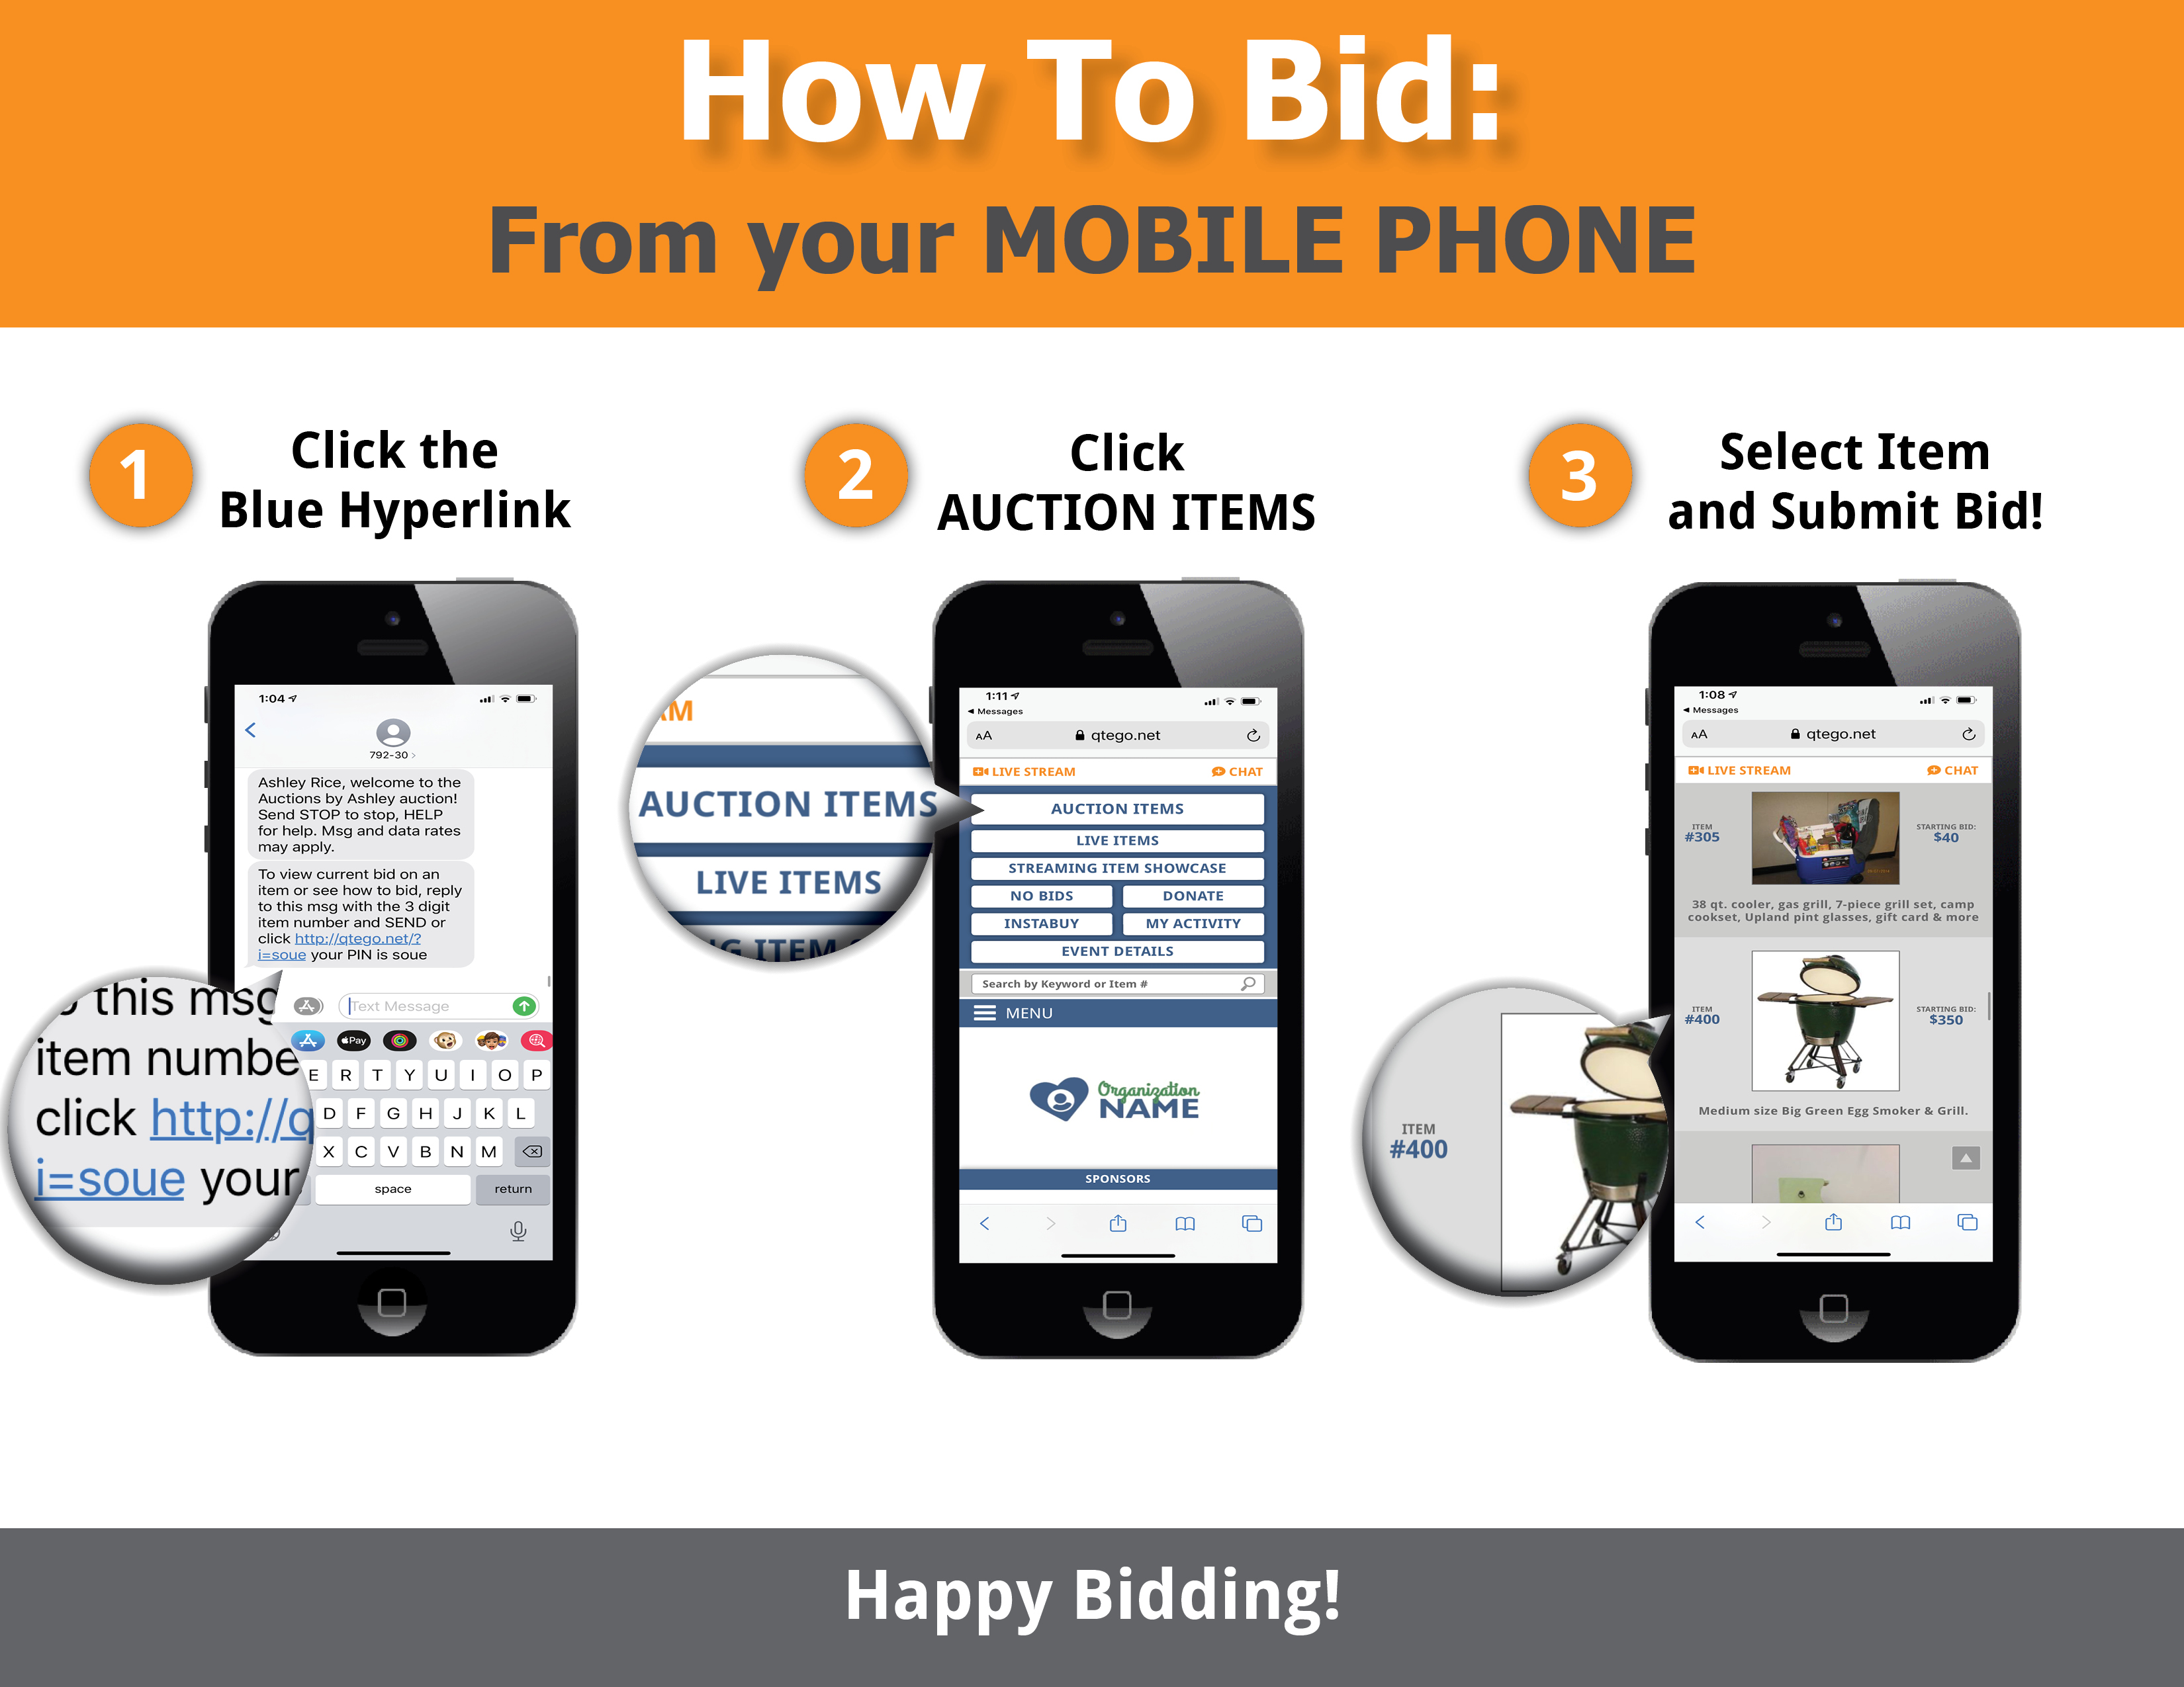
Welcome to BVMI Golf Classic event. We have partnered with Qtego Fundraising Services, so you can place bids directly on your mobile phone, tablet or computer. To register for the auction, please follow these simple instructions:

Step 1: Register
Register your phone number and credit card at: https://qtego.net/qlink/bvmi
Once you register, Qtego will send you two text messages to the phone number you registered with bidding instructions.

Step 2: Start Bidding!

